“Stories connect us” – a new campaign to get Birmingham teenagers reading.
Birmingham hub manager, Kyle Turakhia, discusses a recent community survey into literacy challenges in Birmingham, and the campaign messages it has generated.
“I’m not a reader”.
“Books aren’t really my thing”.
“I can’t read anyway”.
As part of our literacy campaign in Birmingham, I regularly give out books at community events. I stand in front of young people with a range of free, brand-new titles – most of which are quickly snapped up and enjoyed.
But some of the teenagers can’t be tempted. I have become familiar with the bored sighs and variations of ‘not for me’ quoted above – which illustrate an entrenched sense of disengagement from books. Simply repeating to these young people that reading is important, or pressing a free book into their hands, will never be enough to break down this barrier. ‘Not a reader’ has become part of their sense of self, and requires more long-term, relationship-led, practice to shift.
In 2019, the National Literacy Trust partnered with the University of Birmingham – to establish a literacy hub dedicated to this work. It focusses on teenagers and adults – and aims to raise engagement with reading. We deliver across the city, but concentrate on the wards of Aston, Erdington, Nechells, King’s Norton and Sparkbrook, which data shows are in the top percentile of literacy deprivation.
Our strategy is place-based – we want to build a campaign for and with the people of those wards. Everything we do, therefore, happens in partnership – working with existing community initiatives to meet people where they are. We (a team of Birmingham resident staff, academics and volunteers) have spent the past few years introducing ourselves to local schools, libraries, youth centres, charities, and residents – collaborating on reading focussed events, workshops, and sustained interventions.
Last year, we decided to take stock of our position and run a community survey about literacy in Birmingham. This had two main objectives:
- To quantify the literacy challenge, as experienced by the practitioners and people we work with across the city
- To develop unifying ‘messages’, which express the value of reading in our community’s own terms; and guide our ongoing activity.
The survey reached 110 practitioners and 373 community participants, which we followed with a meeting with 20 partner organisations to draft new campaign messages based on the results; and a vote run in five youth centres across the city, to assess which of these slogans was most popular.
The survey and follow up consultations ultimately prompted us to focus our campaign on the theme of connection – and led to three core campaign messages:
Stories connect us
Reading connects us to opportunities
Reading connects us to our interests
This report will summarise the survey and process we used to arrive at these messages.

Community survey results
Birmingham is a big city – a patchwork of diverse communities. Literacy in Birmingham is therefore a local issue – but decidedly not uniform; with infrastructures and challenges differing from ward to ward and street to street.
We therefore wanted to build a picture of literacy among our audience specifically – and develop campaign themes that as many organisations as possible would find valuable.
Our survey, which ran from December 2022 until January 2023, was distributed among the practitioners working in our target wards and the programme participants with which they work. It is a data set drawn from the very communities we aim to reach – working in, or accessing schools, libraries, youth centres, civic initiatives, foodbanks, and other frontline services in Birmingham.
It captured the views of 373 participants (teenagers and adults), and 110 practitioners.

The literacy issue: a snapshot of need
We asked those surveyed about their experience of barriers to literacy.
- 93% of community practitioners said the people they work with struggled with reading, writing or communicating
- 58% of participants said they sometimes struggle with reading, writing or communication
We drilled down into which literacy skills people struggled with most (reading, writing or speaking and listening) and found an interesting balance across these competencies.
- 39% of practitioners said the people they work with struggle ‘most’ with reading, closely followed by 31% choosing writing, and 31% communication.
- 15% of participants said they would like support with reading skills, 27% writing skills and 34% communication.
Comments left under the questions helped to illuminate the experience of these challenges. One young person wrote:
“I (sic) have read all the books in my house already so [there’s] nothing else that i can read”.
While a practitioner summarised that, because of literacy challenges:
“[The people I work with] effectively have a life-limiting disability because so many things are shut off from them .”

Where should we focus?
Our hub was founded to focus on reading for pleasure – as a lever to increase literacy skills generally. Our survey suggested that reading for pleasure is indeed a challenge in Birmingham – with one in two practitioners saying that the people they worked with don’t enjoy reading.
To explore the causes of their disengagement with reading, the survey provided practitioners and participants with a series of reasons they or their audience might not read at home as well as messages that might motivate them to read. These were analysed thematically, identifying the key challenges. The findings indicate three major challenges for reading engagement, which are analysed below:
- Challenge 1: Difficulty finding interesting reading materials
- Challenge 2: Distractions and lack of time
- Challenge 3: Low ‘value’ ascribed to reading for pleasure

Figure 1: Survey of participants
Now thinking about reading... What might stop you from reading at home? Please tick all that apply.
Answer Choices |  |  | Response Percent | Response Total
1 | I can’t find things to read that interest me |  | 39.89% | 146
2 | I don't have enough time |  | 32.51% | 119
3 | I’m too busy using my phone or laptop |  | 28.69% | 105
4 | I don’t enjoy reading |  | 19.95% | 73
5 | I am not a confident reader |  | 10.93% | 40
6 | I don’t think it’s important to read in my spare time |  | 7.92% | 29
7 | Books available don't represent my identity |  | 7.65% | 28
8 | I can't afford to buy books or other reading materials |  | 7.10% | 26
9 | There aren’t any suitable reading materials in my home |  | 5.74% | 21
10 | I can't access a local library to borrow books or other reading materials |  | 5.74% | 21
(Control) | None of the above |  | 8.74% | 32

Figure 2: Survey of practitioners
What do you think might stop the people you work with from reading for pleasure? Please choose all that apply.
Answer Choices |  |  | Response Percent | Response Total
1 | They're too busy using digital devices |  | 62.26% | 66
2 | They are not a confident reader |  | 55.66% | 59
3 | They don’t enjoy reading |  | 52.83% | 56
4 | They don’t think it’s important to read in their spare time |  | 52.83% | 56
5 | There aren’t any suitable reading materials in their home |  | 50.94% | 54
6 | They can’t find texts that interest them |  | 48.11% | 51
7 | They can't afford to buy books or other reading materials |  | 48.11% | 51
8 | Books available don't represent their identity |  | 32.08% | 34
9 | They don't have enough time |  | 26.42% | 28
10 | They can't access a local library to borrow books or other reading materials |  | 17.92% | 19
(Control) | Other (please specify): |  | 7.55% | 8

Challenge 1: Difficulty finding interesting reading materials
Among participants, the most selected barrier to reading (38.9%) was ‘I can’t find things to read that interest me’. This was also chosen by almost half of practitioners (48%: see figures 1 and 2).
In a follow up question, nearly half (47%) of participants said they would be encouraged to read more if they could access books or other reading materials that focused on their interests while 3 in 10 (29%) said they would like books or other reading materials recommended to them. When we asked about potential campaign messages, nearly half (46%) of participants and nearly 7 in 10 (67%) of practitioners liked the theme ‘reading connects you to your interests’. (See figures 3 and 4).
Reading is a fantastic tool to connect us with our interests, and our survey showed that this could be better communicated in Birmingham. These results also display the logical point that providing people with access to books is not enough – if none of those books appeal to them!

Challenge 2: Distractions and lack of time
1 in 3 (33%) of participants said that they don’t have enough time to read, and nearly 3 in 10 (29%) that they are too busy using their phone or laptop. Likewise, more than 3 in 5 (63%) practitioners perceived their communities as too busy using digital devices.
Appended comments showed that the problem of distractions isn’t confined to technology, however. One participant described how their time was instead spent attending “clubs or […]going to town or meeting a family friend”. Others spoke of “lots of homework”, “too many distractions” or being “too busy playing football”.
Whether via digital devices or activities – it seems that participants prioritised social connection over the usually solitary activity of reading.
An interesting counterpoint to this problem was found when we asked practitioners which campaign themes resonated with their work. ‘Empathy and storytelling’ was the most popular choice (chosen by 1 in 2 practitioners).
Taking these findings together, it seems there is an opportunity to show that stories are tools to facilitate, rather than inhibit, social connections and wellbeing. Two practitioners highlighted this point articulately in the comments:
“We want young people to express themselves and their identities but also feel connected to others through reading - it would greatly improve literacy rates and overall academic success.”
“We have been using books to bring neighbours together, to share ideas and to offer ways for people to build on their literacy whilst also having agency to make informed choices in their lives.”

Challenge 3: Low ‘value’ ascribed to reading for pleasure
More than half of practitioners (52.83%) reported that the people they work with don’t think it’s important to read in their spare time. Comments in both surveys clarified this issue – as poor perceptions of the links between reading and academic success.
One young person wrote, for example:
“My A-levels do not require me to read books to improve my writing skills therefore reading seems pointless”.

Likewise, a practitioner wrote:
“[…] A lot of [our] young people believe they do not need numeracy and literacy skills when in reality, they do and will not progress on their vocational courses without them.”
Furthermore, when we asked those surveyed about messages to motivate them to read, “Reading more often can help me to do well at school or in my studies” was the most popular for participants (61%) and third choice for practitioners (57%) (see figures 3 and 4).
Throughout our campaign so far, we have consciously avoided discussion of academic and professional success as a ‘reason to read’; opting instead to emphasise the holistic value of reading for pleasure. These results suggested that this decision may have been misplaced – that our communities want to hear about the life opportunities reading can create.

Figure 3: Survey of participants
Next you will see some statements about reading. Please tell us which ones you feel sound nice. (Please tick all that apply).
Answer Choices |  |  | Response Percent | Response Total
1 | Reading more often can help me to do well at school or in my studies. |  | 61.38% | 213
2 | Reading more often can help my mental wellbeing. |  | 51.30% | 178
3 | Reading more often can make me happy. |  | 49.57% | 172
4 | Reading more often can help me connect with my interests. |  | 45.82% | 159
5 | Reading more often can help me to get a job. |  | 30.55% | 106
6 | Reading more often can help me to help others. |  | 26.22% | 91

Figure 4: Survey of practitioners
And what ’reason to read’ do you think would motivate the people you work with to read more? Please choose all that apply. Reading more often will...
Answer Choices |  |  | Response Percent | Response Total
1 | Help their mental wellbeing. |  | 74.77% | 80
2 | Connect them with their interests. |  | 67.29% | 72
3 | Help them with their studies or at school. |  | 57.01% | 61
4 | Make them happy. |  | 53.27% | 57
5 | Help their career. |  | 44.86% | 48
6 | Help them to help others. |  | 27.10% | 29
 |  |  | answered | 107
 |  |  | skipped | 3

Consultation meeting to draft campaign messages
Having reviewed the survey findings, we organised a community consultation meeting with local partners, to discuss how the results should shape our campaign and messages.
The meeting was held on 15 June 2023 at the Library of Birmingham, and attended by 20 representatives of Birmingham secondary schools, libraries, publishers, charities, business and community organisations.
We presented our findings, and specifically the three local ‘challenges’, listed above. The attendees then brainstormed some campaign messages to respond to these issues – to be used alongside and to shape events, programmes and materials encouraging reading for pleasure in our Birmingham hub.
It was a lively evening of debate and development, culminating in four message proposals.
- Find yourself reading
- Stories create connections
- We read to know we’re not alone
- Reading is resilience

Votes on messages at local youth centres

To make a final decision on our new campaign, we visited youth centres in Sparkbrook, Nechells, Aston and King’s Norton: as part of our series of ‘Literacy Takeover’ events.
Using stickers on a poster, we asked young people to vote on which of our proposed messages would encourage more people in Birmingham to read.
The results showed that messages (2) and (3) were most popular.
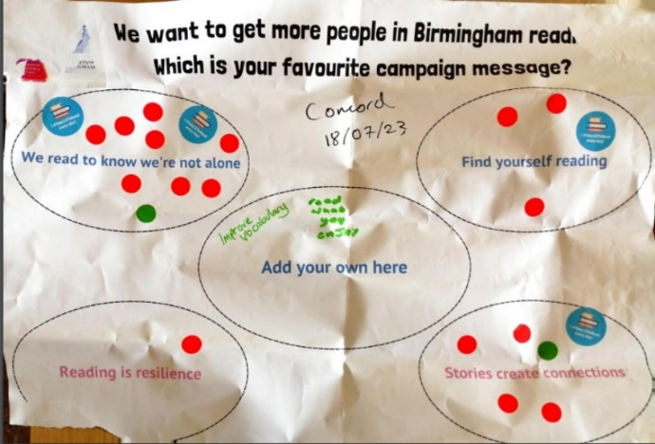
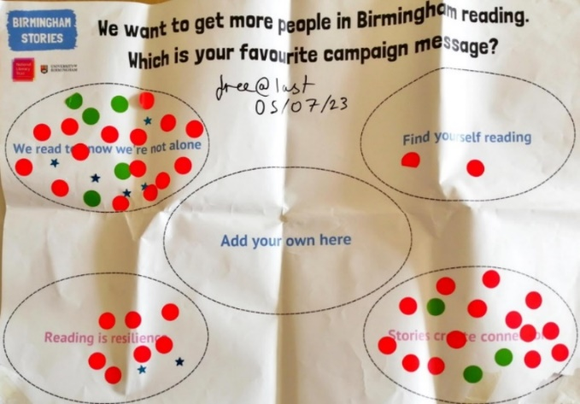
Figure 5: Sticker voting at youth centres

Stories connect us – what next?
Both of the popular messages – ‘stories create connections’ and ‘we read to know we’re not alone’– focus on bringing people together.
We combined these ideas to create three interconnected campaign slogans – responding to the literacy barriers indicated in our surveys.
Figure 6: Campaign messages as responses to our challenges.
Challenge | Message
Challenge 1: Difficulty finding interesting reading materials | Reading connects us to our interests
Challenge 2: Distractions and lack of time/sense that reading is not a social activity | Stories connect us
Challenge 3: Low ‘value’ ascribed to reading for pleasure | Reading connects us to opportunities

I am excited to organise our work around these new slogans – as rallying cries to encourage young people and adults to read for pleasure in Birmingham. The messages work because literacy is the great connector – relevant to our hobbies, social lives and ambitions.
It is important to reiterate that these messages will never be used in isolation – they are designed to tie into our events, programmes and resources providing supportive routes towards reading for pleasure.
The difference is that now, if young people ask: ‘but why should I read’ – at a Birmingham sports club, school, community centre or foodbank we can respond in one voice:
…because stories connect us!

Written by Kyle Turakhia
Birmingham Hub Manager
October 2023

https://literacytrust.org.uk/policy-and-campaigns/all-party-parliamentary-group-literacy/literacy-score-mapping-literacy-need-across-england/

