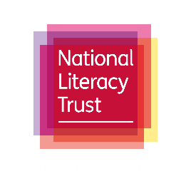

Advertising opportunities

Advertising with the National Literacy Trust can provide your organisation with a unique opportunity to access engaged literacy professionals who are not otherwise accessible to third parties.
Please see our different options below:
National Literacy Trust website  - Our website literacytrust.org.uk has over 50,000 monthly unique users  - The main audience for our website is UK education professionals  - Visitors use the site for literacy resources, research, news and policy updates.  - News stories focus on current news about our work and literacy in the UK  - Blog articles appear on the blog page of our website. These are more personal and are linked to a current issue or event  Costs to advertise:  - Sponsor a news story with an image to appear on the www.literacytrust.org.uk homepage: £400 + VAT  - Write a guest blog (www.literacytrust.org.uk/blog) with image: £400 + VAT | Social media  - We have 77,000 Twitter followers and post between five and 10 times a day  - We have 13,000 likes on Facebook and we post once every day  - Our posts are image-led and cover our work, literacy trends and news of interest to our followers  - Our followers include teachers, librarians, corporate representatives and publicists  Cost to advertise:  - A package of 4 tweets and 1 Facebook post: £500 + VAT
Monthly newsletter  - We have 30,000 subscribers to our monthly newsletter  - Audience includes teachers, education professionals, librarians, businesses and publishers  - Newsletter content includes updates on our programmes and research, events, literacy news and case studies  Costs to advertise:  - £500 for one month, £1,200 for three months, £2,500 for six months  - 50 words of copy and a link | Words for Life website  - Our parent-facing site, Words for Life has 100,000 monthly unique users  - Content includes milestones in communication development, tips and fun activities help parents to support their children’s literacy skills  - Quarterly themes feature in-depth content on a particular topic e.g. comic books or festive-themed activities  Costs to advertise:  - A news article with an image: £350  - Sponsorship of a theme: from £4,000

For more information or to book your advert, please email advertise@literacytrust.org.uk.

